OOP Lab Practical – 3

Name: Divyam Kumar

SAPID: 500083141

Roll No: R214220434

Batch: B2

**Title: Basic Java Programming**

1. Write a program to take input ( a number) of a month (1 - 12) and print its equivalent name of the month.( e.g 1 to Jan, 2 to Feb. 12 to Dec.) Use Scanner class for user input( Hint-use switch case)
2. Write a program to add two number using command line arguments.
3. Write a program to implement a command line calculator.
4. Write a program to accept three digits (i.e. 0 - 9) and print all its possible combinations. (For example if the three digits are 1, 2, 3 than all possible combinations are : 123, 132, 213, 231, 312, 321.)

Q1:

ALGORITHM

Step 1: START

Step 2: initialise choice as an integer variable

Step 3: Display “Enter any number from 1 to 12”

Step 4: Accept user input for variable choice

Step 5: Implement switch case with 12 cases with each case displaying corresponding month

Step 6: Print (“Divyam Kumar \n 500083141)

Step 7: END

CODE:

import java.util.*;

class Month

{

public static void main(String[] args) {

Scanner in = new Scanner(System.in);

System.out.println("Enter the Month Number: ");

int a = in.nextInt();

switch(a)

{

case 1:

System.out.println("January");

break;

case 2:

System.out.println("Feburary");

break;

case 3:

System.out.println("March");

break;

case 4:

System.out.println("April");

break;

case 5:

System.out.println("May");

break;

case 6:

System.out.println("June");

break;

case 7:

System.out.println("July");

break;

case 8:

System.out.println("August");

break;

case 9:

System.out.println("September");

break;

case 10:

System.out.println("October");

break;

case 11:

System.out.println("November");

break;

case 12:

System.out.println("December");

break;

default:

System.out.print("Invalid Input");

break;

}

System.out.print("Divyam Kumar \n500083141");

}

}

OUTPUT:

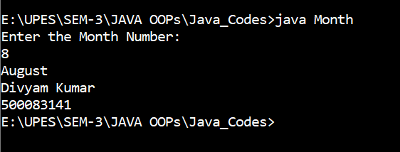

Q2:

ALGORITHM

Step 1: START

Step 2: Initialise a, b and c as Integer variables

Step 3: Assign values to a and b by accepting user input from command line using arguments

Step 4: Find sum using, c=a+b

Step 5: Display sum by printing c

Step 6: Print (“Divyam Kumar \n 500083141)

Step 7: END

CODE:

class CommandLineAdd{

public static void main(String args[])

{

int a = Integer.parseInt(args[0]);

int b = Integer.parseInt(args[1]);

int c = a+b;

System.out.println("Sum c is: "+c);

System.out.print("Divyam Kumar \n500083141");

}

}

OUTPUT:

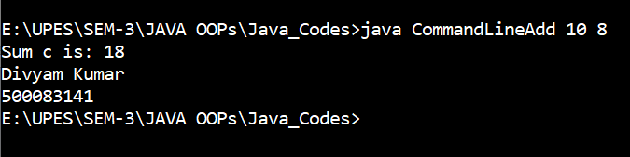

Q3:

ALGORITHM

Step 1: START

Step 2: Initialise a and b as integer variables

Step 3: Assign values to a and b by accepting user input from command line using arguments.

Step 4: Calculate the sum of 2 numbers

Step 5: Calculate the difference between the number

Step 6: Calculate the product of the number

Step 7: Divide the numbers

Step 8: Print the results of the calculations

Step 9: Print (“Divyam Kumar \n 500083141”)

Step 10: END

CODE:

class Cal

{

public static void main(String[] args) {

double a,b;

a = Integer.parseInt(args[0]);

b = Double.parseDouble(args[1]);

System.out.println("Addition: "+(a+b));

System.out.println("Substraction: "+(a-b));

System.out.println("Multiplication: "+(a*b));

System.out.println("Division: "+(a/b));

System.out.print("Divyam Kumar \n500083141");

}

}

OUTPUT:

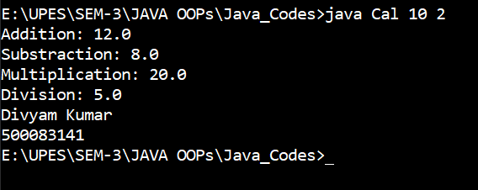

Q4 :

ALGORITHM

Step 1: START

Step 2: Initialise a, b, c, i, j, k as Integer variables

Step 3: Accept user input values for a, b and c between 0-9

Step 4: Initialise an integer array with a, b and c assigned to it

Step 5: create 3 nested for loop (i, j, k) from 0-3 to get indices of the array

Step 6: Check if indices values in i, j and k are same

* If same don’t print and continue
* If not same then Print the numbers in each index of i, j and k

Step 7:Print (“Divyam Kumar \n 500083141”)

Step 8: END

CODE:

import java.util.*;

class Comb

{

public static void main(String[] args)

{

Scanner in = new Scanner(System.in);

int a = in.nextInt();

int b = in.nextInt();

int c = in.nextInt();

int [] d = {a,b,c};

for(int i= 0; i<3;i++)

{

for(int j= 0; j<3;j++)

{

for(int k= 0; k<3;k++)

{

if(i!=j && j!=k && k!=i)

System.out.println(d[i]+" "+d[j]+" "+d[k]);

}

}

}

System.out.println("DivyamKumar \n500083141");

}

}

OUTPUT:

